**SQL assignment**

Name: Anushree Manoj

Reg no: 2337011

**Dataset 1: the Iowa liquor sales dataset**

Q1. All the stores having bottle volumes greater than 20?

SELECT store_name

 FROM `bigquery-public-data.iowa_liquor_sales.sales`

 WHERE bottle_volume_ml > 20

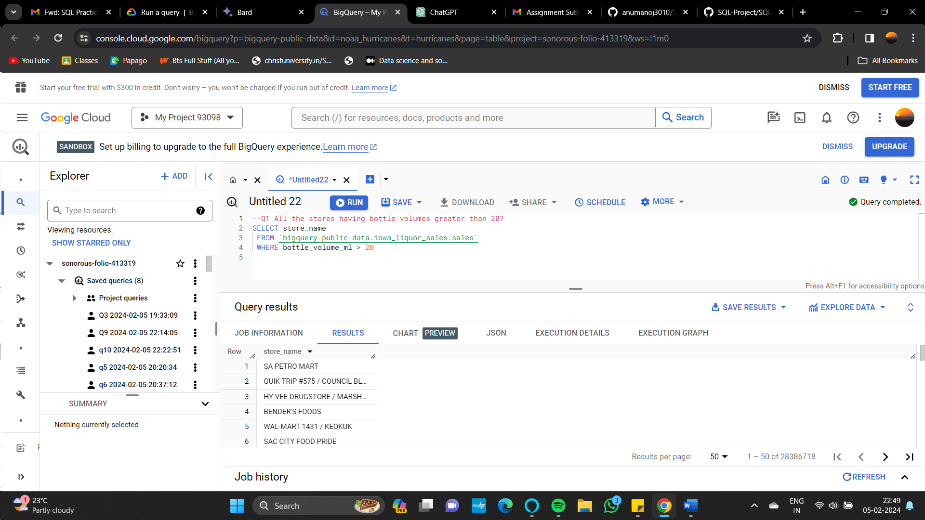

Q2. All the stores that don’t sell whiskey liquer?

SELECT store_name

FROM `bigquery-public-data.iowa_liquor_sales.sales`

WHERE category_name <> 'WHISKEY LIQUEUR';

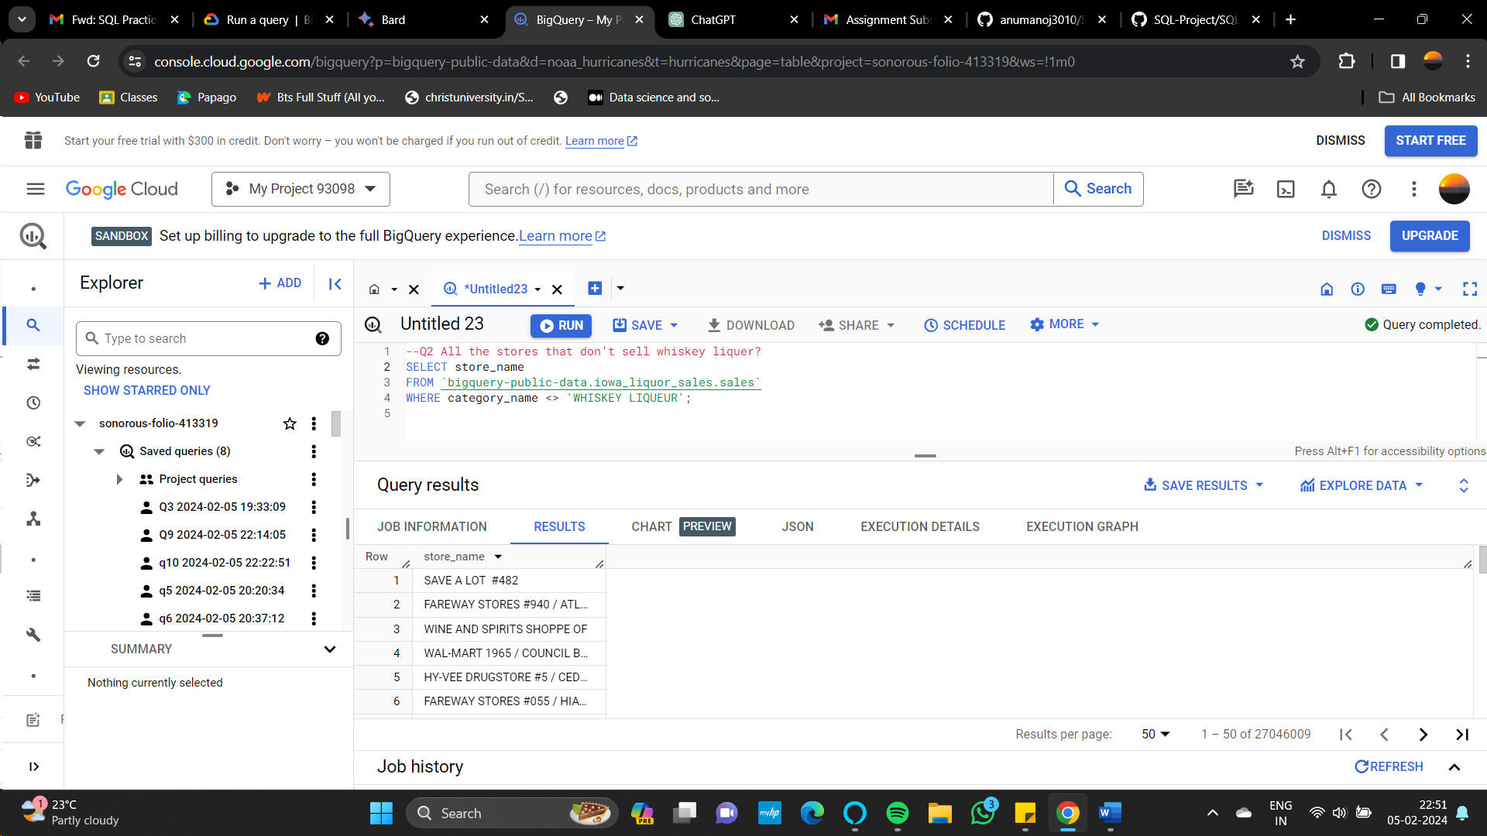

Q3. Name all the vendor selling the item ’99 fruits mini’ with bottle volumes less than 50?

SELECT vendor_name

FROM `bigquery-public-data.iowa_liquor_sales.sales`

WHERE item_description = '99 FRUITS MINI'

AND bottle_volume_ml = 50;

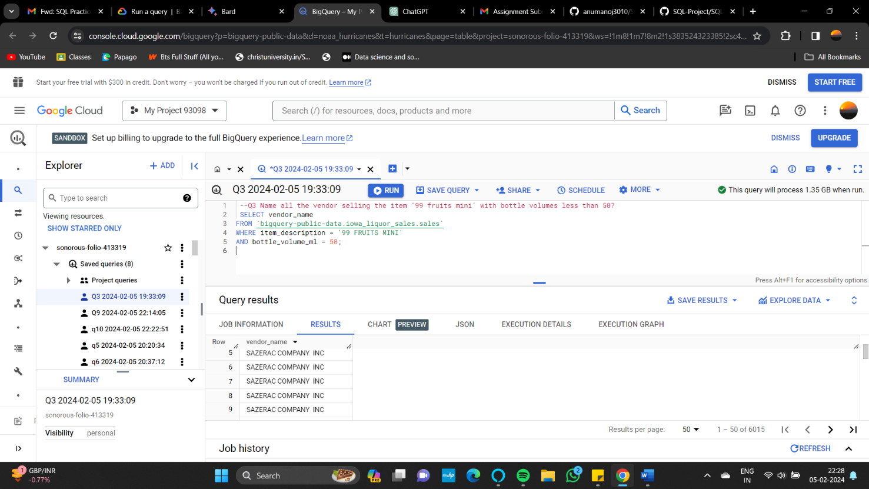

Q4. What is the count of liquor categories for each item where the pack size is 10 in the Iowa liquor sales dataset?

SELECT item_description, COUNT(category_name) AS liquer_count

FROM `bigquery-public-data.iowa_liquor_sales.sales`

WHERE pack = 10

GROUP BY item_description;

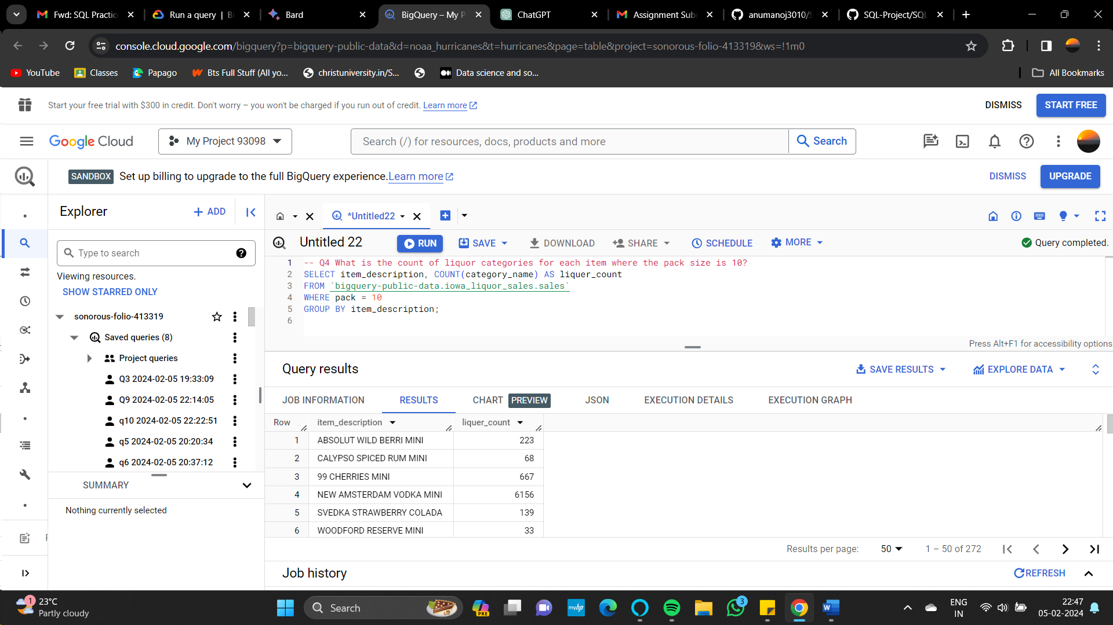

Q5. How many occurrences are there in the Iowa liquor sales dataset where the category is 'BLENDED WHISKIES' and the sale dollars are 77.4?

SELECT COUNT(*) AS count_occurrences

FROM `bigquery-public-data.iowa_liquor_sales.sales`

WHERE category_name = 'BLENDED WHISKIES' AND sale_dollars = 77.4;

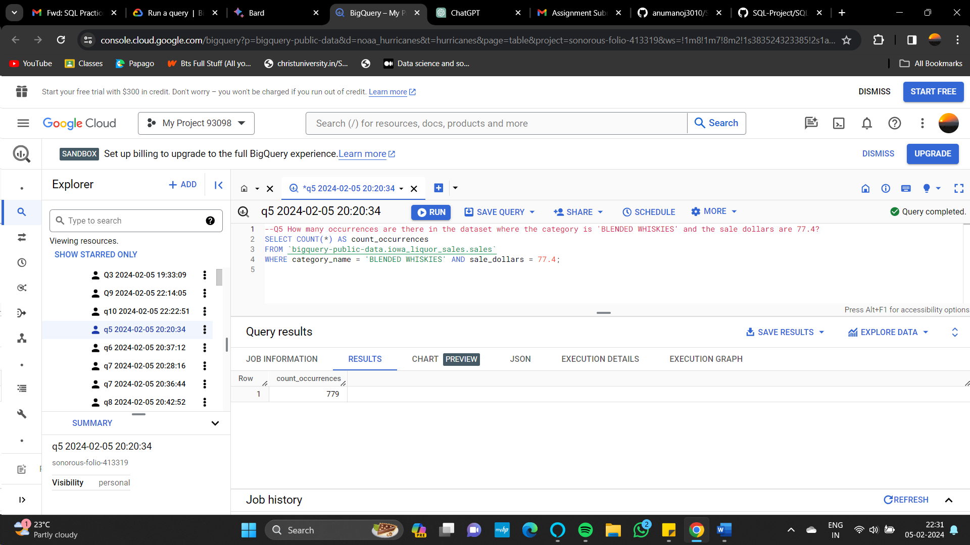

Q6. What are the item_descriptions and vendor_names of items in the Iowa liquor sales dataset where the sale dollars are greater than 100?

SELECT `item_description`, `vendor_name`

FROM `bigquery-public-data.iowa_liquor_sales.sales`

WHERE sale_dollars > 100;

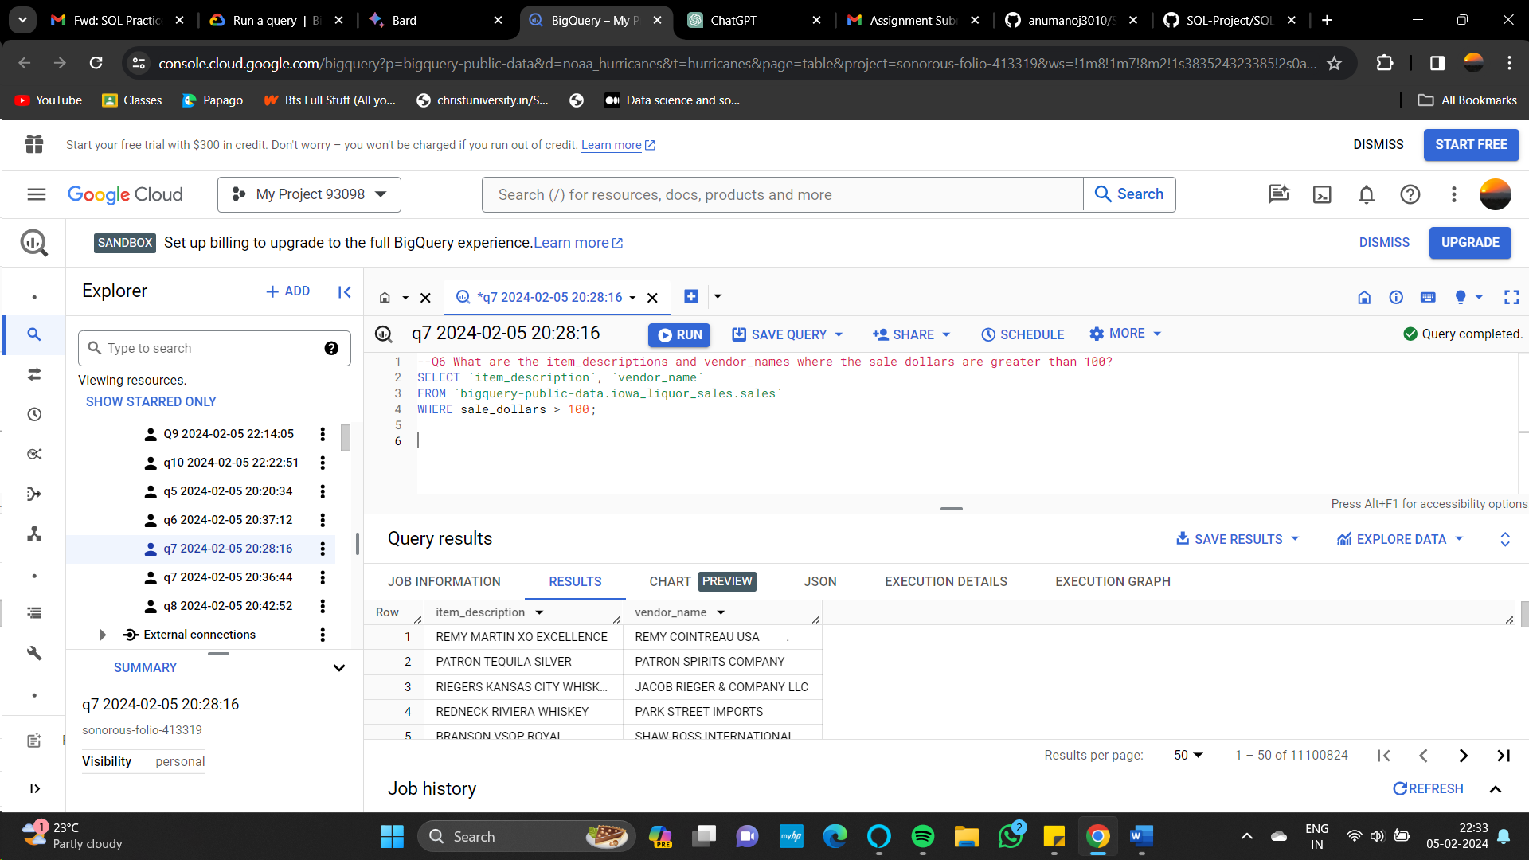

Q7. What are the category_name values in the Iowa liquor sales dataset where the vendor_numbers are equal to '421'?

SELECT category_name

FROM `bigquery-public-data.iowa_liquor_sales.sales`

WHERE vendor_number = '421';

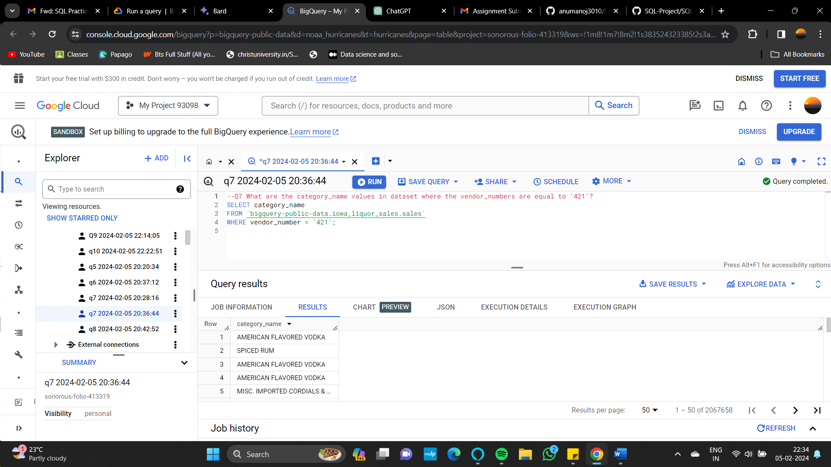

Q8. In which stores in the dataset, the item 'CROWN ROYAL PEACH MINI' is sold?

SELECT store_name

 FROM `bigquery-public-data.iowa_liquor_sales.sales`

 WHERE item_description = 'CROWN ROYAL PEACH MINI'

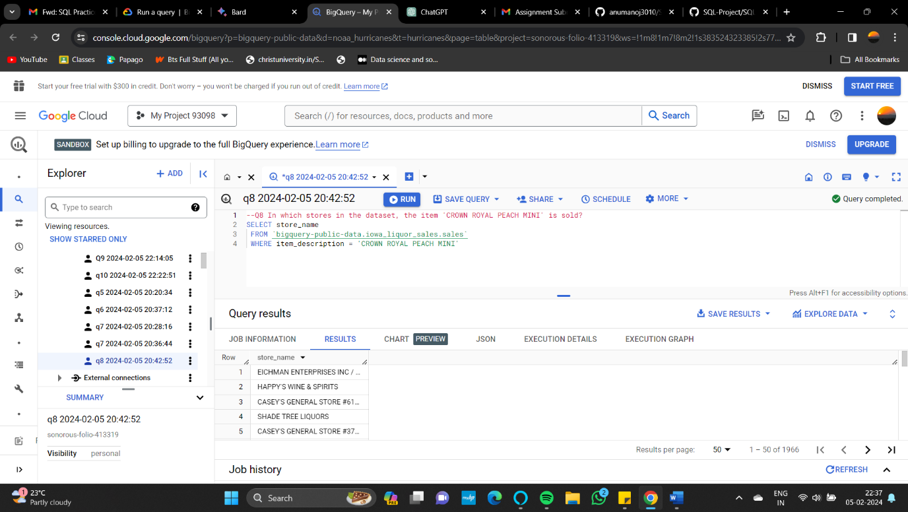

**Dataset 2: the Austin Bikeshare dataset**

**Join queries**

Q9. How many trips start at each bikeshare station in Council District 9 in the dataset?

SELECT A.start_station_id, COUNT(A.trip_id) AS trip_count

FROM `bigquery-public-data.austin_bikeshare.bikeshare_trips` A

LEFT JOIN `bigquery-public-data.austin_bikeshare.bikeshare_stations` B

ON A.start_station_id = B.station_id

WHERE B.council_district = 9

GROUP BY A.start_station_id;

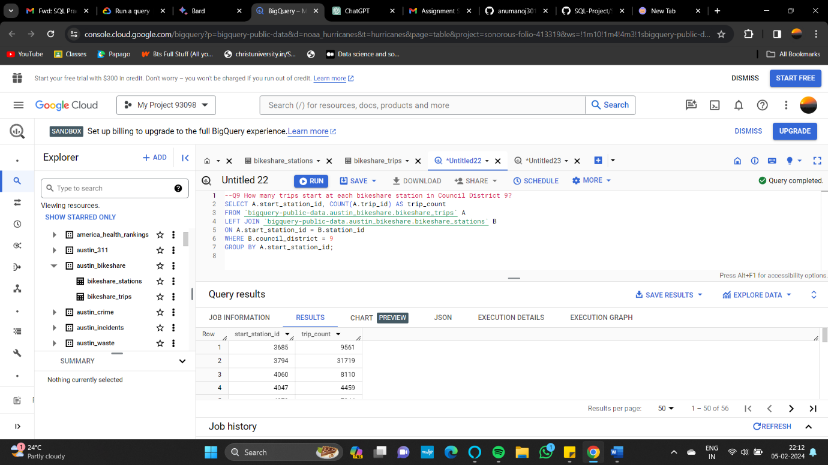

Q10. What are the names of bikeshare stations in Austin where the trips have a duration greater than 10 minutes and are marked as 'active'?

SELECT start_station_name

FROM `bigquery-public-data.austin_bikeshare.bikeshare_trips` A

LEFT JOIN `bigquery-public-data.austin_bikeshare.bikeshare_stations` B

ON A.start_station_id = B.station_id

WHERE duration_minutes > 10 AND status = 'active'

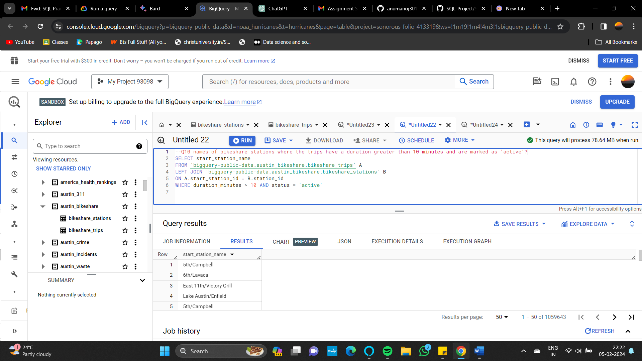

**Query links:**

<https://console.cloud.google.com/bigquery?sq=383524323385:3b2732e6809f4f0db351a60f1cc3850a>

<https://console.cloud.google.com/bigquery?sq=383524323385:20b1725b1203471ea1e3f38d6b863652>

<https://console.cloud.google.com/bigquery?sq=383524323385:c48a342ff5f443b5ac1929b588de3ac5%27>

<https://console.cloud.google.com/bigquery?sq=383524323385:1579bf52d64549378a94761a913f25ae>

<https://console.cloud.google.com/bigquery?sq=383524323385:1aa92670b71f4a82a009d0574be143e7>

<https://console.cloud.google.com/bigquery?sq=383524323385:b17e4ad237a147318e21aefb9eaa482c>

<https://console.cloud.google.com/bigquery?sq=383524323385:3a9e25fcd1d3479fa2e8c181cfc444d8%27>

<https://console.cloud.google.com/bigquery?sq=383524323385:770ea039c58541f98d8d340f12d23e5f%27>

<https://console.cloud.google.com/bigquery?sq=383524323385:ca72f9b09f5a49bc9f48d66888501e23>

<https://console.cloud.google.com/bigquery?sq=383524323385:328f7f5020cb4a7598ef788471e06c87>